Sets are used as a way of grouping items such as objects, items, numbers, letters, and even statements. And like arithmetic and algebra, operations can be performed on sets.

Set operations are done between two or more sets.

**EXAMPLE:** Two people are running in an election for City Council. Each person has created their list of campaign promises for the public. Here is what they promise:

**Honest Amy Dependable Dave**

Spend less money – Spend less money –

Enforce traffic laws to increase money – Improve school buildings, build new –

Hire more police officers – Improve benefits for city employees –

Decrease city taxes – Increase jobs, bring in businesses –

Improve bad neighborhoods – Hire more police officers –

Set of Amy’s promises**:** Set of Dave’s promises**:**

A = D =

**I. Intersection:**

* Look at their lists. Do they share any common promises? If so, which ones? ________

_____________________________________________________________________

* Now, look at their sets. Do you see any elements in common? If so, which ones? ____

_____________________________________________________________________

* Common elements in each set is called an ______________________

* The symbol for intersection is**:**
* Write in symbol form the intersection of Amy’s set of promises and Dave’s set of promises:

**II. Union:**

* Looking at their lists. The newspaper is writing an article listing **all** campaign promises made during this election. What is that list of **all** promises?

____________________________ ____________________________

____________________________ ____________________________

____________________________ ____________________________

____________________________ ____________________________

* Now look at their sets, list **all** the elements in the two sets: _______________________
* **All** the elements in each set is called a ______________________

* The symbol for union is**:**
* Write in symbol form the union of Amy’s set of promises and Dave’s set of promises:

Venn Diagrams of the Intersection and Union of Amy’s and Dave’s campaign promises**:**

**Intersection Union**

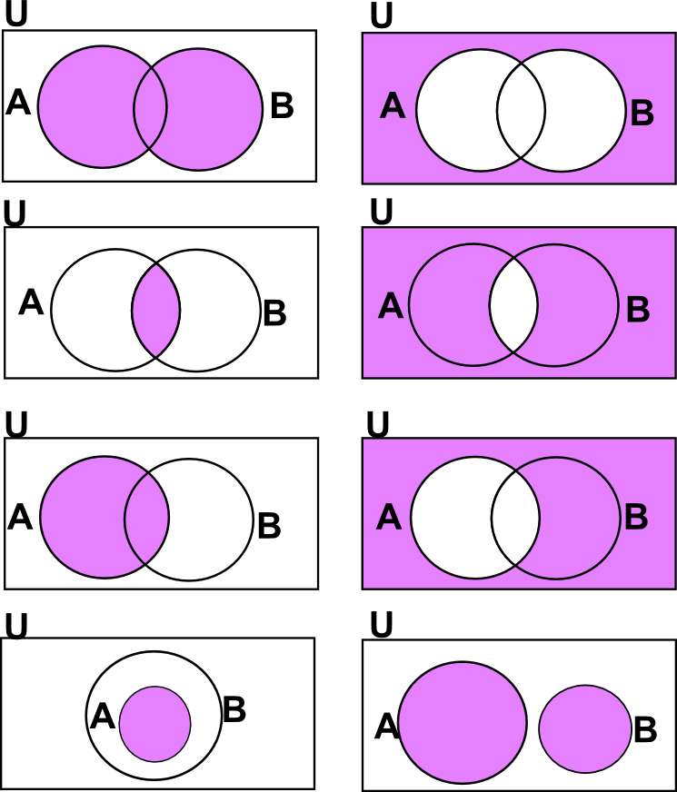

**A D A D**

**EXAMPLE:** find the intersection of the given sets

1. {2, 3, 4, 5, 6, 7} ∩ {2, 4, 6, 8} =

2. {1, 3, 5, 7} ∩ {2, 4, 6, 8} =

3. {math, English, history, biology, computers} ∩ {history, math, chemistry, accounting} =

**EXAMPLE:** find the union of the given sets

1. {3, 4, 5, 6, 7} ∪ {1, 2, 3, 4} =

2. {4, 5, 6} ∪ {7, 8, 9} =

3. {purple, blue, yellow, orange} ∪ {yellow, pink, blue, purple} =

**EXAMPLE:** find the union or intersection of the given sets.

U = {1, 2, 3, 4, 5, 6}

A = {1, 2, 3, 4}

B = {2, 4, 6}

C = {3, 4, 5, 6}

1. A ∪ B =

2. B ∩ C =

3. A**′** ∩ B =

4. B**′** ∪ C =

5. A ∩ (B ∪ C**′**) =

**III.** ________ ______________ can represent all kinds of information. They can show sets, subsets, intersections, and unions. Venn diagrams are one of many ways to organize information and show relationships, such as, items in common or not in common, similarities or differences.

**Examples of information organization**

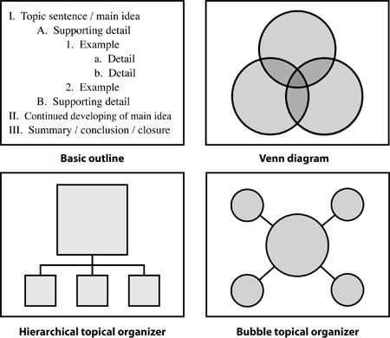

**Examples of Venn Diagrams**

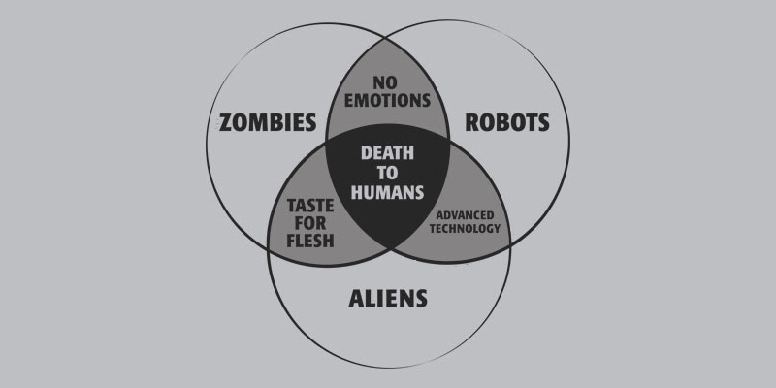

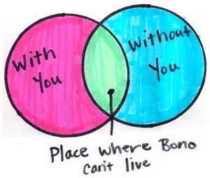

**EXAMPLE:** Shade the resulting area of the Venn diagram

**A′ ∪ B (A ∩ B) ∪ C′**

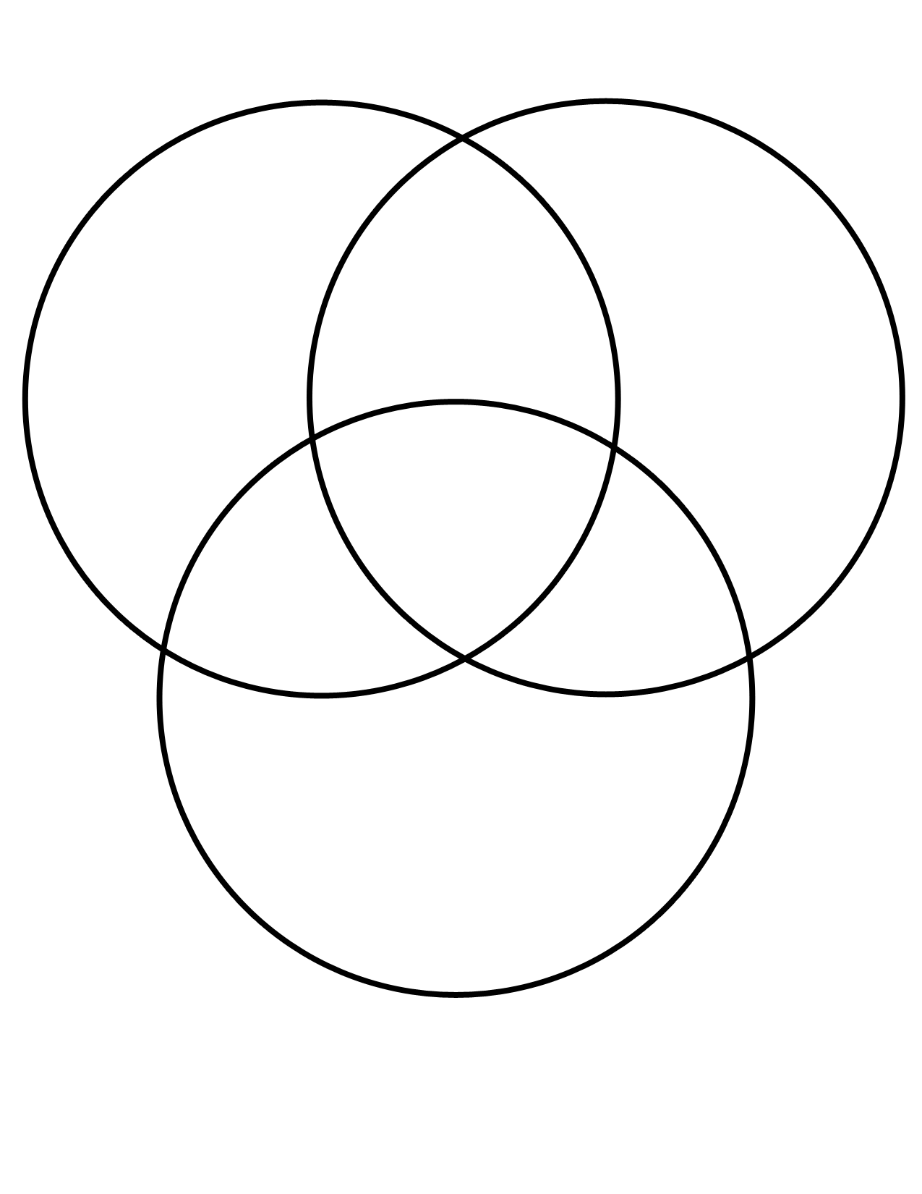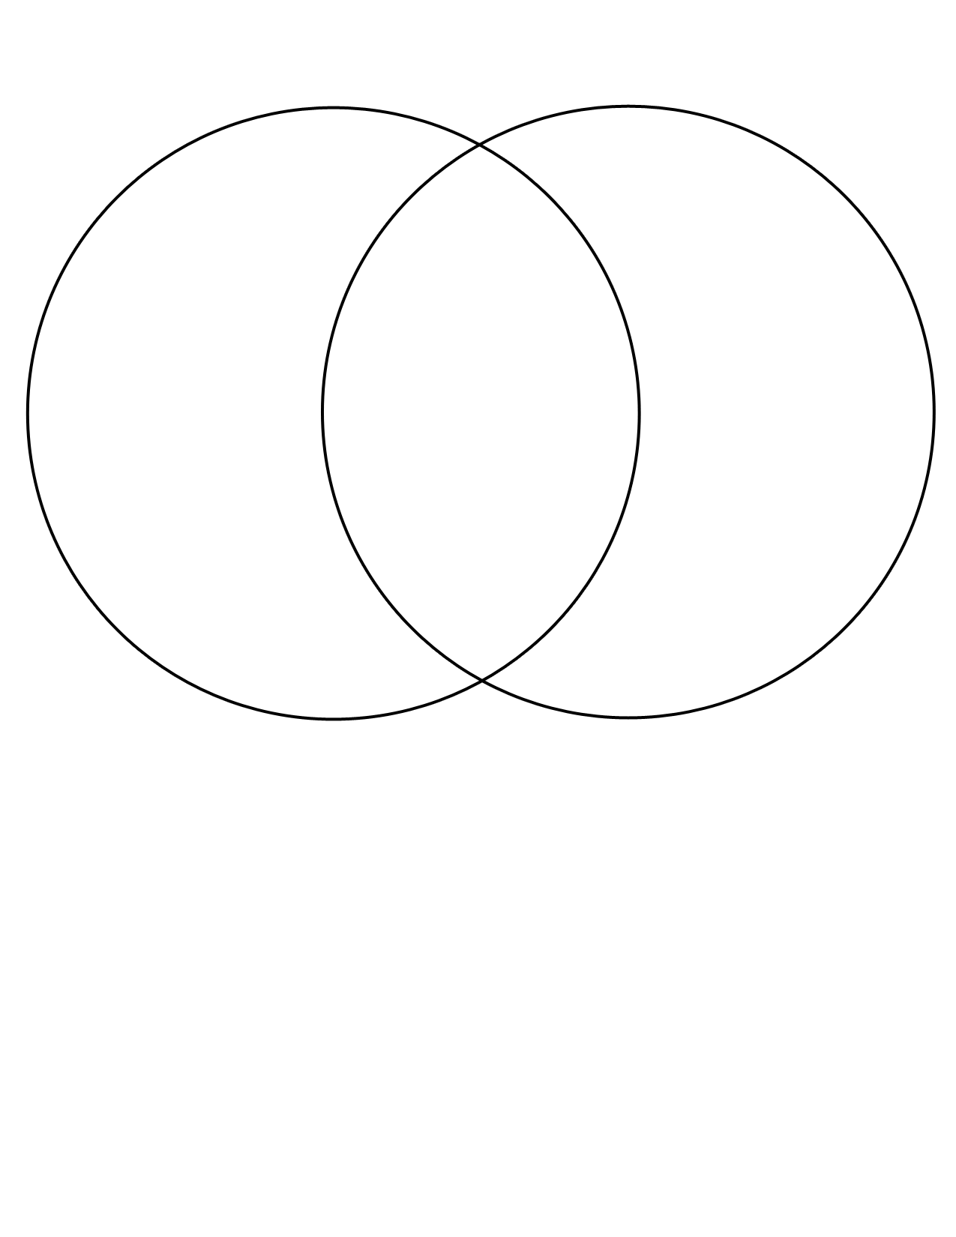

**IV.** Difference of sets: _______________________________________________________

_______________________________________________________________________

_______________________________________________________________________

_______________________________________________________________________

**EXAMPLE:** find the difference of the two sets

A = {1, 2, 3, 4, 5, 6, 7, 8, 9, 10} B = {2, 3, 6, 7, 9}

What is A – B? {1, 4, 5, 8, 10}

**EXAMPLE:** find the difference of the sets

U = {1, 2, 3, 4, 5, 6}

A = {1, 2, 3, 4}

B = {2, 4, 6}

C = {3, 4, 5, 6}

1. A – B =

2. B – C =

3. C – B =

**V.** Sometimes in math, things are paired together and the order is important. Just like an ordered pair (point). An ordered pair has two numbers in a specific order (x, y).

_________________ _______________is creating a set of ordered pairs from the elements of two sets.

___________________________________________________________________________

___________________________________________________________________________

**EXAMPLE:** find the Cartesian Product

A = {1, 2, 3} B = {4, 5}

What is A x B?

What is B x A?

Is A x B = B x A?

